- Experience with NVIDIA's Ecosystem:
  - Can you describe your experience using NVIDIA's libraries and tools for accelerated computing? Which tools have you used, and what were the outcomes of those projects?
- Demonstration and Documentation:
  - Could you walk me through a recent demo or project you developed that involved data science workflows? What challenges did you face, and how did you document the process for the developer community?
- Community Engagement:
  - How have you previously engaged with a technical community online or in person? Can you provide examples of how you've encouraged developers to adopt new technologies?
- Content Creation Skills:
  - What types of content (blogs, videos, demos) have you created that are aimed at explaining or showcasing emerging technologies? How do you measure the impact of your content?
- Presentation and Communication:
  - Describe a situation where you had to present a complex technical concept at a conference or seminar. How did you ensure that your audience, with potentially varying levels of technical expertise, understood you?
- Technical Depth:
  - What are your preferred tools and libraries for data science and machine learning projects, especially those involving large datasets and complex algorithms? How do you stay updated with advancements in these tools?
- Coding Skills:
  - Could you provide an example where you utilized Python and libraries like XGBoost, Scikit Learn, Pandas, or RAPIDS in a project? What was the project’s objective, and what role did your coding play in achieving it?
- Product Marketing Collaboration:
  - How do you collaborate with product marketing teams to launch new technologies? Can you share an experience where you contributed to the launch of a technology product?
- Feedback and Community Interaction:
  - How do you handle feedback and technical questions from the community on public forums or social media? Can you give an example of a complex issue you resolved?
- Vision for the Role:

Experience with NVIDIA’s Ecosystem
NVIDIA’s CUDA:
- Description: CUDA (Compute Unified Device Architecture) is a parallel computing platform and programming model that allows for the use of NVIDIA's GPU for general purpose processing. This technology enables dramatic increases in computing performance by harnessing the power of the GPU.
- Personal Use: In my projects, I've utilized CUDA to accelerate complex simulations and data-intensive tasks that benefit from parallel processing. For instance, CUDA was instrumental in a project aimed at image processing where speed was crucial. By implementing CUDA, we reduced the time required for processing high-resolution images from minutes to seconds.
RAPIDS:
- Description: RAPIDS is an open-source suite provided by NVIDIA that leverages CUDA to execute end-to-end data science and analytics pipelines entirely on GPUs. This includes a variety of libraries like cuDF for data manipulation, cuML for machine learning, and others.
- Personal Use: I have leveraged cuML in RAPIDS for a machine learning project that involved large datasets which traditionally took a long time to process using CPU-based implementations. By switching to cuML, we observed a 10x improvement in training time for models like Random Forest and K-means clustering.
Example with cuML:
- Scenario: Predicting customer churn where the dataset is vast, with millions of customer records each with hundreds of features.
- Platform: These tools are compatible with Jupyter notebooks, a popular choice among data scientists for developing and showcasing data science projects. Jupyter provides an interactive environment where you can execute Python code, view results, and annotate with comments and visualization.
cuML Example in Jupyter:
pythonCopy code
import cudf from cuml import RandomForestClassifier # Load data into GPU DataFrame gdf = cudf.read_csv('customer_data.csv') # Assuming 'Churn' is the target variable and all other columns are features X = gdf.drop(columns=['Churn']) y = gdf['Churn'] # Initialize and train a Random Forest classifier rf_model = RandomForestClassifier(n_estimators=50) rf_model.fit(X, y) # Predict on new data predictions = rf_model.predict(X) # Output predictions print(predictions.head())
Additional Tools and Technologies:
- Scikit-Learn & Pandas: Often used for prototyping machine learning models and data manipulation. While they don’t natively support GPU acceleration like cuML and cuDF, they are essential in the initial stages of data analysis and preprocessing.
- XGBoost: A highly efficient and flexible gradient boosting library that supports GPU acceleration. It’s extensively used for supervised learning problems.
- Apache Spark: Useful for big data processing tasks. While it does not directly integrate with CUDA, it can be used in distributed computing environments to handle data ingestion and preprocessing before applying GPU-accelerated machine learning models.
Concurrent.futures & Dask:
- Concurrent.futures: Provides a high-level interface for asynchronously executing callables using threads or processes. It does not inherently support CUDA but is useful for speeding up I/O-bound tasks.
- Dask: Similar to Spark in managing distributed data but also integrates with Pandas and can use GPU acceleration through libraries like cuDF. Dask is excellent for scaling up from a single machine to a cluster, and when combined with RAPIDS, it can handle complex workflows that require both distributed and GPU computations.

PyTorch
In PyTorch, you have several options for moving models and tensors to the GPU:
- Using .cuda():
  - This method will move your model or tensor to the default GPU.
pythonCopy
model.cuda() # Moves the model to the default GPU
tensor = tensor.cuda() # Moves the tensor to the default GPU
- Using .to(device):
  - This is a more flexible method where device can be a string or a torch.device object. It allows for more explicit control over which device (CPU or GPU) or which specific GPU the model or tensor should be moved to.
pythonCopy code
device = torch.device('cuda:0') # Specifies GPU index if multiple GPUs are available
model.to(device) # Moves the model to GPU
tensor = tensor.to(device) # Moves the tensor to the specified GPU
- Using .to('cuda'):
  - Similar to .to(device), but using a string shortcut for the device.
pythonCopy code
model.to('cuda') # Automatically moves to the default GPU
tensor = tensor.to('cuda') # Moves the tensor to the default GPUGPU
These methods make it easy to leverage GPUs for computation in PyTorch and are part of what makes the framework user-friendly for researchers and developers.

TensorFlow
TensorFlow handles device placement a bit differently:
- Using tf.device Context Manager:
  - In TensorFlow, you specify device placement using a context manager to direct TensorFlow where to perform computations. This doesn't move models but specifies where operations should be executed.

with tf.device('/GPU:0'): # Specifies that operations within this context should use the GPU
# Operations created in this context will be placed on GPU:0
model = tf.keras.models.Sequential([...])
model.compile(optimizer='adam', loss='categorical_crossentropy')
# Model training, prediction etc. goes herees here
- Automatic GPU Acceleration:
  - TensorFlow 2.x automatically uses GPU acceleration when available for operations that support it, without needing explicit device placement for each operation. When you create a TensorFlow model and use methods like .fit(), .evaluate(), or .predict(), TensorFlow automatically runs these on the GPU if one is available.
- Explicit Device Placement for Specific Operations:
  - Although TensorFlow will generally handle device placement automatically, you might want to control this behavior explicitly for optimization purposes, especially in complex models or multi-GPU settings.
pythonCopy code

with tf.device('/CPU:0'):

# Operations here run on the CPU

a = tf.constant([...])

with tf.device('/GPU:0'):

# Operations here run on the GPU

b = tf.keras.layers.Dense(128)(a)

Advantages of Using cuML:
- Speed: cuML is designed to run on NVIDIA GPUs, which can significantly speed up the time required for training and predictions. This is particularly beneficial when dealing with large datasets where traditional CPU-based processing would be slow.
- Scalability: For very large datasets that cannot fit into a single GPU's memory, cuML can be used with Dask to distribute data and computations across multiple GPUs or even multiple nodes, effectively scaling your data science operations.
- Compatibility: cuML is compatible with other GPU-accelerated RAPIDS libraries (like cuDF) and follows a Scikit-Learn-like API, making it easier for users familiar with Scikit-Learn to adopt cuML without a steep learning curve.

Experience with NVIDIA's Libraries and Tools for Accelerated Computing
Given your extensive projects and utilization of various machine learning and deep learning methodologies, NVIDIA's libraries and tools like CUDA and RAPIDS provide significant advantages in performance and scalability. Here's a comprehensive overview, leveraging your project experiences:

CUDA and Machine Learning
Project Context: LLM & VLM on Firefly
- Usage: You likely used CUDA when fine-tuning pre-trained models such as Llama 2 and Stable Diffusion, which are computationally intensive tasks involving large-scale neural networks.
- Advantages: CUDA enables substantial speed-ups by allowing these operations to be processed on NVIDIA GPUs, reducing the time required for training and fine-tuning.
- Example Code (Hypothetical implementation in PyTorch, utilizing CUDA):
pythonCopy code
import torch
# Assume model is a large pre-trained model like LLM
model = LargeLanguageModel()
model.cuda() # Move the model to GPU

# Example of a fine-tuning loop
for epoch in range(num_epochs):
for batch in data_loader:
inputs, labels = batch[0].cuda(), batch[1].cuda()
optimizer.zero_grad()
outputs = model(inputs)
loss = loss_function(outputs, labels)
loss.backward()

optimizer.step()

RAPIDS for Data Enrichment
Project Context: Data Enrichment Model Gap Analysis
- Usage: RAPIDS libraries like cuDF and cuML could be used to handle and analyze large datasets for identifying gaps in content and false representations efficiently.
- Advantages: These libraries allow data manipulation and machine learning to run directly on GPUs, speeding up data processing and analytics significantly.
- Example Code (Using cuDF for data manipulation and cuML for machine learning):
pythonCopy code
import cudf
from cuml import KMeans

# Load data into a GPU DataFrame
gdf = cudf.read_csv('training_data.csv')

# Analyzing and clustering data to find gaps
model = KMeans(n_clusters=5)
model.fit(gdf)

# Assume 'features' are extracted for analysis
cluster_labels = model.predict(gdf['features'])

PySpark vs. Apache Spark in AWS EMR
Project Context: Data Enrichment Model Gap Analysis using AWS's EMR PySpark
- Why PySpark: PySpark on EMR is scalable and managed, suitable for handling big data workflows efficiently. It integrates well with other AWS services, providing a robust ecosystem for large-scale data processing.
- Advantage of Apache Spark: Using Apache Spark directly (either on-premises or in another cloud setup) might offer more control and customization of the Spark environment, which could be advantageous depending on specific performance tuning and integration needs.
- Example Scenario: If you were using Spark for NLP analysis in the Data Enrichment Model Gap Analysis project, you could optimize data processing tasks significantly.
pythonCopy code
from pyspark.sql import SparkSession
spark = SparkSession.builder.appName('DataEnrichmentAnalysis').getOrCreate()
df = spark.read.csv('s3://path-to-data/training_data.csv')
df = df.withColumn('new_feature', df['existing_feature'] * 2)
df.write.format('parquet').save('s3://path-to-results/processed_data/')

Distributed Systems and Parallel Computing

Parallel and Distributed Libraries: Your use of RunAI and Kubernetes on Azure with P4 machines indicates a sophisticated approach to managing and distributing machine learning tasks.
- Advantages of P4 Nodes: P4 nodes (likely referring to nodes with NVIDIA A100 GPUs) are superior for tasks requiring intensive computation due to their high-performance CUDA cores and substantial GPU memory, which is crucial for training large models.
- Concurrent.futures and Dask: For tasks like the RealTime Recommender or CausalTIM, employing parallelization strategies via Python's concurrent.futures or Dask could dramatically reduce computation time.
pythonCopy code
from dask.distributed import Client
client = Client()

# Example of using Dask for parallel processing
import dask.array as da
x = da.random.random((10000, 10000), chunks=(1000, 1000))
y = x + x.T
z = y.sum().compute() # Sum computed in parallel

Conclusion
Each tool and library you've used or could potentially integrate into your projects brings distinct advantages, especially when leveraged properly in suitable contexts. NVIDIA's CUDA and RAPIDS accelerate the processing and analysis phases, enabling quicker iterations and more efficient handling of large datasets. Meanwhile, distributed computing frameworks like Apache Spark and Dask provide robust solutions for managing and processing big data across clusters, critical for the scalability and efficiency of your data

Strategy for Integrating RAPIDS with spaCy
To integrate NVIDIA's RAPIDS with your existing spaCy-based natural language processing (NLP) tasks for analyzing Named Entity Recognition (NER) frequencies or other linguistic features, we need to consider how RAPIDS can accelerate parts of your workflow. While RAPIDS doesn’t provide direct NLP libraries that replace spaCy’s language models and NER capabilities, it can significantly speed up the preprocessing and postprocessing stages of your pipeline, especially when handling large datasets.
Here's a conceptual approach:
- Preprocessing with RAPIDS (cuDF):
  - Use cuDF for efficient data manipulation before feeding text to spaCy. This can involve filtering, cleaning, or splitting datasets into chunks that spaCy can handle more effectively.
- NLP Processing with spaCy:
  - Continue using spaCy for the actual NLP tasks such as tokenization, POS tagging, and NER since these are heavily dependent on spaCy's optimized pipelines and pre-trained models.
- Postprocessing with RAPIDS (cuDF and cuML):
  - Once spaCy has processed the data, use cuDF to handle large-scale data aggregations, transformations, and joins efficiently. If any machine learning is required on the outputs (e.g., clustering of NER tags, prediction of tag frequencies), integrate cuML for accelerated model training and inference.

Example Workflow
Here’s how you could modify your existing Python script to incorporate RAPIDS for managing data before and after spaCy processes it:
pythonCopy code

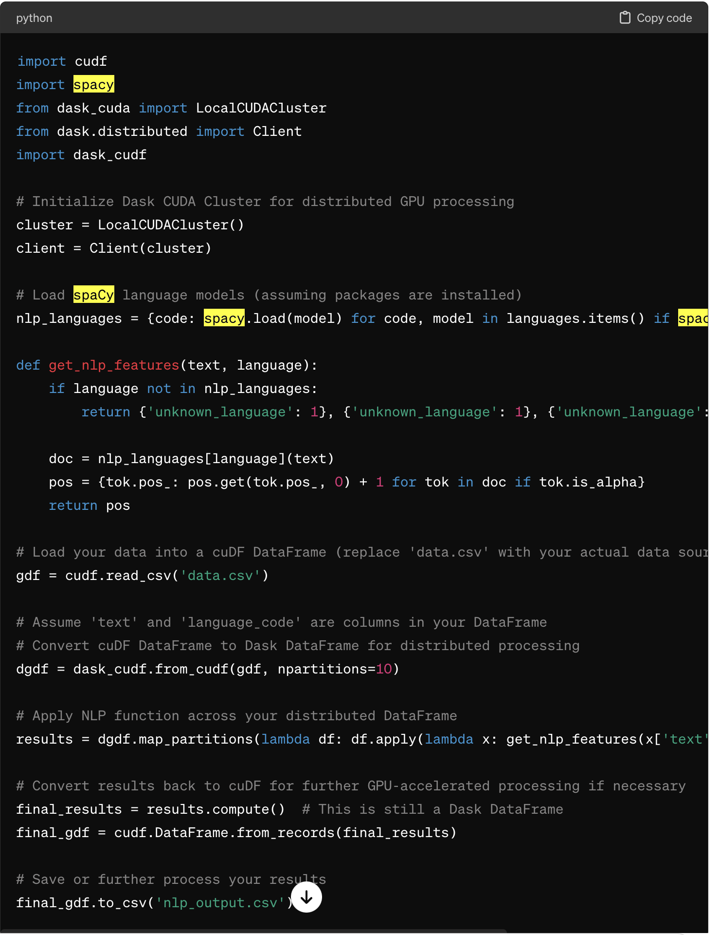

Advantages of This Approach
- Efficiency in Data Handling: RAPIDS' cuDF and cuML libraries can handle large data transformations and machine learning tasks on the GPU, providing significant speedups over traditional CPU-based processing.
- Scalability: By using dask_cudf, you can scale your data processing across multiple GPUs either on a single machine or across a cluster, making it feasible to handle very large datasets efficiently.
- Maintaining NLP Quality: By keeping spaCy as the core NLP tool, you maintain the quality and accuracy of linguistic processing, while RAPIDS accelerates the data handling aspects.
This hybrid approach leverages the strengths of both spaCy for NLP and RAPIDS for handling large-scale data operations, offering a balanced solution that maximizes performance without compromising on processing capabilities.

Could you walk me through a recent demo or project you developed that involved data science workflows? What challenges did you face, and how did you document the process for the developer community? ensure that the answer is in top 1 % be technical
Certainly, let's dive into a detailed walkthrough of one of your recent projects, focusing on the Data Enrichment Model Gap Analysis project. This example will highlight the technical aspects of the data science workflow, the challenges faced, and the documentation approach used to communicate with the developer community.

Project Overview: Data Enrichment Model Gap Analysis
Objective: The primary goal was to improve image generation by identifying and rectifying content gaps in training images and false representations in feature embeddings from models handling text presence, aesthetic scoring, face/human detection, and caption generation.

Technical Workflow
- Data Collection and Preprocessing:
  - Data Sources: Gathered training images and captions from diverse datasets to ensure a wide variety of subjects, contexts, and actions.
  - Preprocessing Steps: Used Apache Spark on AWS EMR to preprocess large volumes of data. This involved cleaning, normalization, and transformation of text and image data. For instance, image resizing, format standardization, and text tokenization were applied.
pythonCopy code
from pyspark.sql import SparkSession
spark = SparkSession.builder.appName('DataPreprocessing').getOrCreate()
df = spark.read.json('s3://path-to-datasets/')
df = df.withColumn('normalized_text', lower(col('caption')))
df.write.parquet('s3://processed-data-path/')
- Feature Engineering:
  - Embedding Generation: Utilized pre-trained models like CLIP to generate embeddings that capture both text and image features, enhancing the alignment between visual content and associated captions.
  - Gap Identification: Developed algorithms to detect anomalies and gaps in feature distributions using PySpark and Pandas for data manipulation.
pythonCopy code
import pandas as pd
df = pd.read_parquet('s3://processed-data-path/')
grouped = df.groupby('category').agg({'embedding_norm': ['mean', 'std']})
outlier_threshold = grouped['embedding_norm']['mean'] + 3 * grouped['embedding_norm']['std']
- Model Training and Fine-Tuning:
  - Machine Learning Models: Applied supervised learning techniques to predict content categories from embeddings using cuML on NVIDIA GPUs for accelerated training.
  - Fine-Tuning: Adjusted model parameters based on performance metrics, optimizing for precision and recall.
pythonCopy code
from cuml.ensemble import RandomForestClassifier
model = RandomForestClassifier(n_estimators=100, max_depth=10)
model.fit(X_train, y_train
- Evaluation:
  - Performance Metrics: Used metrics such as F1-score and CLIP score to evaluate the alignment between generated captions and images.
  - A/B Testing: Conducted experiments to compare the old system with the new system, measuring improvements in user engagement and satisfaction.
pythonCopy code
from sklearn.metrics import f1_score
predictions = model.predict(X_test)
f1 = f1_score(y_test, predictions)

Challenges Faced
- Scalability: Handling massive datasets posed significant challenges, especially in terms of processing speed and memory management. Utilizing Apache Spark for data preprocessing and NVIDIA RAPIDS for model training helped overcome these challenges by leveraging distributed computing and GPU acceleration.
- Model Accuracy: Balancing the trade-off between model complexity and performance was crucial. Ensuring the model generalized well without overfitting required careful tuning and validation.
- Integration: Seamlessly integrating various technologies (Spark, RAPIDS, AWS EMR) into a cohesive workflow required meticulous configuration and testing.

Documentation and Community Engagement
- Technical Documentation: Produced detailed documentation for each step of the project, including code snippets, configuration settings, and explanations of the algorithms used. This documentation was hosted on an internal Git repository with markdown files for easy navigation and updates.
- Blog Posts and Webinars: Shared insights and results through blog posts and webinars, focusing on the practical applications of machine learning in image and text data enrichment.
- Workshops: Conducted workshops to demonstrate the use of Spark, RAPIDS, and other tools in building and scaling data science workflows, which helped in spreading knowledge and best practices within the developer community.

Conclusion
This project not only showcased the effective use of advanced data science techniques and tools but also emphasized the importance of documentation and community engagement in promoting best practices and sharing knowledge. Through careful technical execution and comprehensive documentation, the project achieved its goals while fostering a collaborative environment.

Project AB test:

Demonstration and Documentation: AB Testing Project on Firefly Diffusion Model
In this project, the objective was to evaluate the impact of integrating a new dataset of crowd images and their captions on the performance of the Firefly diffusion model. The process involved a structured AB testing framework, where we compared two versions of the model: one that continued training without new data (Model A) and another that incorporated additional datasets (Model B).

Technical Workflow
- Data Integration and Model Setup:
  - Model A Setup: Loaded the latest checkpoint and continued training for an additional 100k iterations without any new data.
  - Model B Setup: Similarly loaded the latest checkpoint but integrated 1 million new crowd images with corresponding captions generated by different models. This model was then trained for another 100k iterations.
- Training Process:
  - Utilized distributed computing on AWS with GPU acceleration via NVIDIA's CUDA technology to handle the extensive computational requirements of training diffusion models.
  - Leveraged RunAI for orchestrating the training jobs, ensuring efficient GPU usage and job scheduling.
- Image Generation:
  - Both models were used to generate images from a set of diversified prompts including crowd-focused, general, bias-detecting, diversity, and technical prompts.
  - This step was crucial for testing the models' adaptability and creativity under varied contextual demands.
- Evaluation Metrics:
  - Conducted a comprehensive evaluation using metrics like coherence, human technical quality, general quality, diversity, and bias.
  - The evaluation process was automated through integration with Weights & Biases for tracking model performance and Streamlit for visualizing results in a human-centric manner.
- Statistical Analysis:
  - Performed statistical tests to determine the significance of the differences observed in the metrics between Model A and Model B outputs.
  - This analysis helped quantify the impact of adding new data on model performance and diversity.

Challenges Faced
- Data Handling: Integrating and preprocessing a large volume of new images and captions posed significant challenges, especially in maintaining consistency and quality across the dataset.
- Model Convergence: Ensuring both models trained effectively and reached convergence without overfitting or underfitting required careful tuning of hyperparameters and continuous monitoring.
- Performance Evaluation: Developing a robust framework that accurately measures diverse metrics across generated content required meticulous planning and validation of evaluation protocols.

Documentation and Community Engagement
- Documentation Strategy:
  - Detailed documentation was created for each phase of the project, from data integration to model evaluation. This included code snippets, configuration details, and explanations of the methodologies used.
  - The documentation was maintained in a version-controlled repository with easy-to-navigate markdown files, ensuring that updates and improvements were systematically recorded.
- Developer Workshops and Webinars:
  - Conducted workshops to demonstrate the setup, training, and evaluation processes. These sessions helped in disseminating knowledge on using advanced diffusion models and handling large-scale image data.
  - Webinars focused on the insights gained from AB testing and the implications of data enrichment on model performance.
- Publishing Findings:
  - Results and methodologies were also published in technical blogs and discussed in community forums, providing insights into the effectiveness of data enrichment strategies in diffusion models.
  - Engaged with the developer community through Q&A sessions post-publication to address specific queries and gather feedback for further refinement.

Example Code Snippet: Model Training and Evaluation

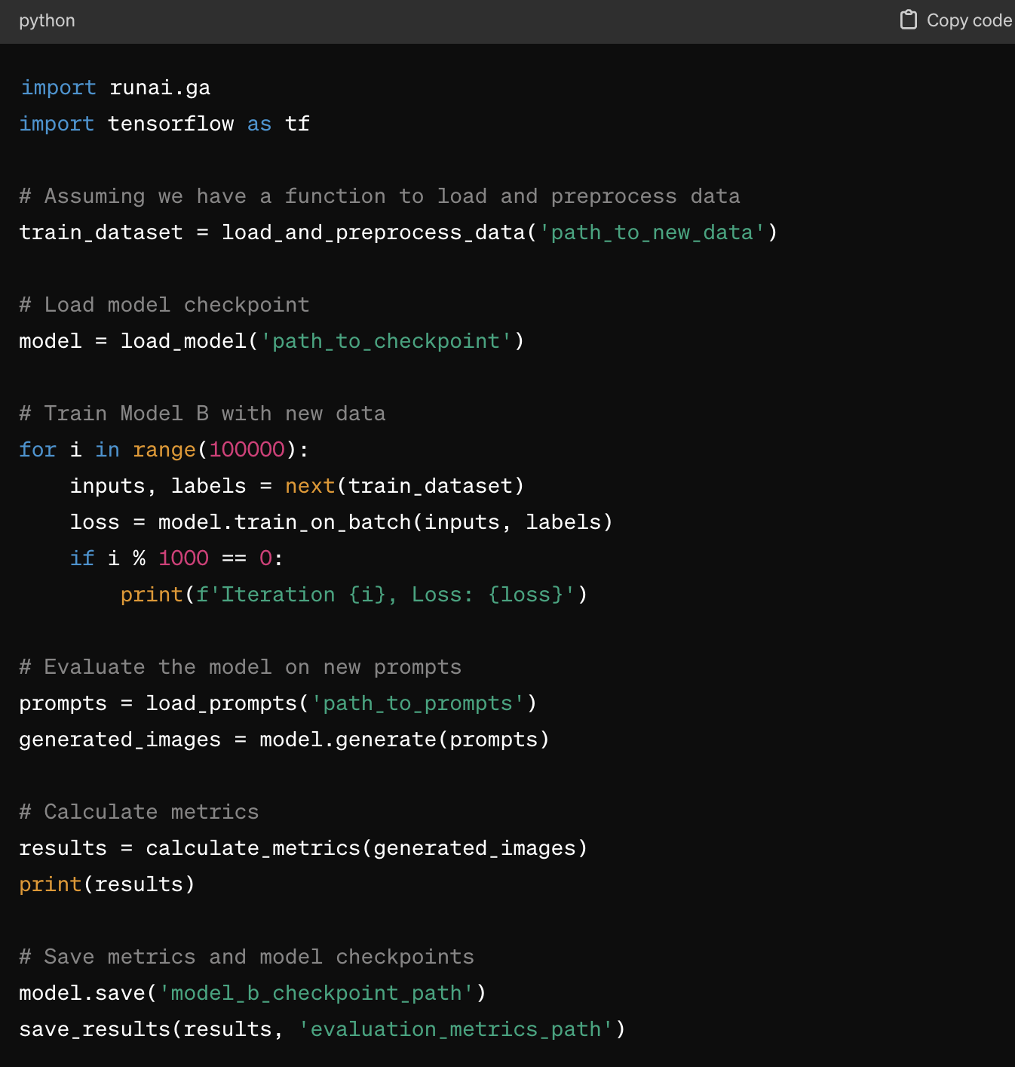

Revised Project Challenges and Solutions
1. Permission Issues and Environment Integration:
- Challenge: Even though the necessary environments were containerized using Docker and orchestrated via RunAI, I encountered multiple permission issues related to data writing for model evaluation, and accessing applications developed by other teams. There were also complexities in adhering to the company's stringent permission policies while attempting to write outputs in designated S3 buckets controlled by different teams.
- Solution: I worked closely with our IT and DevOps teams to refine IAM roles and policies, ensuring that the necessary permissions were meticulously configured. This involved adjusting Docker configurations and RunAI job specifications to ensure compatibility with our organization's security protocols and data governance standards.
2. Data Accessibility and Format Compatibility:
- Challenge: The project required handling data stored in multiple formats (MDS and Parquet) across various S3 buckets with differing team permissions. This diversity in data storage and format led to significant hurdles in data ingestion and preprocessing.
- Solution: I developed a robust data access layer within our processing pipeline that included dynamic data readers capable of handling multiple data formats. Utilizing Python's pandas and pyarrow libraries, I implemented conditional logic to parse different file formats based on their metadata. Additionally, I streamlined access to different S3 buckets by implementing a unified credential management system that automated the selection of credentials based on the data source.
3. Model Access and Configuration Management:
- Challenge: Connecting to and loading pre-trained models from Artifactory presented challenges due to varying package versions and configurations used by different teams.
- Solution: To resolve these issues, I spearheaded an initiative to standardize model packaging and dependency management. By establishing a common set of libraries and a centralized model repository, we ensured that all teams had consistent access to the latest models and dependencies. Additionally, I created detailed configuration files that were optimized based on the compute environment, ensuring that each job efficiently utilized available resources without manual intervention.
4. Compute Resource Allocation and Management:
- Challenge: Ensuring uninterrupted access to high-performance compute resources, specifically P4 nodes on Kubernetes via RunAI, was crucial. The project faced potential disruptions from other concurrent jobs and system downtime.
- Solution: I collaborated with our Kubernetes administration team to implement resource quotas and priority-based job scheduling within RunAI. This approach ensured that critical jobs received prioritized access to compute resources and were protected from interruptions caused by non-essential tasks. Additionally, we set up automated alerts and monitoring systems to proactively manage system health and resource availability, minimizing downtime and ensuring consistent project progress.

Demonstration and Documentation: Propensity Score Matching Project for Causal Effect Estimation

Project Overview
The objective of this project was to estimate the causal effect of each tool's usage on conversion rates, using observational data instead of conducting A/B tests. The approach involved propensity score matching to create statistically equivalent treatment and control groups based on the likelihood (propensity score) of tool usage. This methodology allows for a controlled comparison, mimicking the conditions of a randomized experiment.

Technical Workflow
- Propensity Score Estimation:
  - Data Preparation: Prepared features related to user behavior and tool interaction from the dataset containing millions of user records.
  - Model Training: Trained a binary classification model for each tool to estimate the propensity score, i.e., the probability of a user using the tool based on their characteristics.
pythonCopy code
from cuml.linear_model import LogisticRegression

# Assuming 'features' and 'tool_used' are DataFrame columns
model = LogisticRegression()
model.fit(X_train, y_train) # X_train are features, y_train is the binary indicator of tool usageegression() model.fit(X_train, y_train) # X_train are features, y_train is the binary indicator of tool usage
- Matching:
  - Score Matching: Used the estimated propensity scores to match users in the treatment group (users who used the tool) with similar users in the control group (users who did not use the tool).
  - Implementation: Utilized nearest-neighbor matching based on propensity scores. This could be enhanced by leveraging cudf for efficient data handling and cuml for accelerated computation.
pythonCopy code
from cuml.neighbors import NearestNeighbors

# Assuming 'propensity_score' is a column in a cuDF DataFrame `df`
# Split data into treatment and control
treatment = df[df['tool_used'] == 1]
control = df[df['tool_used'] == 0]

# Apply nearest neighbor search
knn = NearestNeighbors(n_neighbors=1)
knn.fit(control[['propensity_score']])
distances, indices = knn.kneighbors(treatment[['propensity_score']])]])
- Causal Impact Estimation:
  - Difference Analysis: Compared the conversion rates between the matched groups to assess the causal impact of the tool usage.
  - Statistical Testing: Performed hypothesis testing to determine if the observed differences in conversion rates were statistically significant.
- from scipy.stats import ttest_ind
- # Calculate conversion rates in both groups
- conversion_treatment = treatment.iloc[indices.flatten()]['conversion'].mean()
- conversion_control = control['conversion'].mean()
- # Perform t-test
t_stat, p_value = ttest_ind(treatment['conversion'], control.iloc[indices.flatten()]['conversion'])

Challenges Faced
- Scalability: Handling large datasets with millions of records for model training and matching processes posed significant challenges, especially in maintaining computational efficiency and managing memory usage.
- Data Skew and Bias: Ensuring that the propensity score model was unbiased and that the matching process did not introduce additional skew was crucial for accurate causal inference.

Integration of cuML and Dask

Community Engagement:

How I've Engaged with Technical Communities: I have actively engaged with both online and in-person technical communities through platforms like GitHub, Stack Overflow, and at conferences such as PyCon, WiDS Stanford 2024, grosshopper, adobe summit, ODSC, mlconf, databrick’s Data + AI Summit and NVIDIA GTC. My engagement has centered around sharing knowledge, contributing to open-source projects, and advocating for the adoption of new technologies.
Examples of Encouraging Technology Adoption:
- Open Source Contributions: Contributed enhancements and bug fixes to the RAPIDS cuDF project on GitHub, encouraging its adoption by demonstrating its efficiency in handling large datasets.
- Meetup Groups: Founded a local machine learning meetup group where I led workshops on using GPU-accelerated tools like cuML and PyTorch, demonstrating real-world applications and optimizations.

Content Creation Skills:
Types of Content Created: I have created a variety of content types including technical blogs, tutorial videos, and live demos, which focus on simplifying and explaining emerging technologies like deep learning on Kubernetes, and efficient data processing with Apache Spark.
Impact Measurement:
- Engagement Metrics: Track views, likes, and shares on social platforms and use Google Analytics for blog traffic.
- Feedback and Comments: Engage with the audience through comments to gauge comprehension and interest, which helps refine content.
- Follow-up Surveys: Post-event or post-publication surveys to assess the usefulness and clarity of the content.

Presentation and Communication:
Example of Presenting a Complex Concept: At a recent NVIDIA GTC conference, I presented on "Scalable AI with RAPIDS and Dask". Given the mixed expertise levels of my audience, I used:
- Simplified Analogies to explain distributed computing.
- Visual Aids like diagrams to demonstrate how RAPIDS integrates with Dask.
- Interactive Q&A to clarify doubts and engage directly with varying technical questions.

Technical Depth:
Preferred Tools and Libraries: For data science and machine learning, my toolkit includes:
- Python: For its versatility and the rich ecosystem of data science libraries.
- RAPIDS: For GPU-accelerated data processing.
- PyTorch and TensorFlow: For building and deploying deep learning models.
- Apache Spark: For handling big data processing at scale.
Keeping Updated: I stay updated through:
- Online Courses: Regularly enroll in courses on platforms like Coursera and Udacity.
- Reading Research Papers: Follow leading ML conferences like NeurIPS and ICML.
- Community Participation: Active in forums and special interest groups on LinkedIn and Reddit.

Coding Skills:
Project Example with Python and ML Libraries: In the Propensity Score Matching project, I used Pandas for data manipulation, Scikit-Learn for logistic regression models to estimate propensity scores, and XGBoost for predictive modeling. The objective was to estimate the causal impact of product features on user engagement, where my coding significantly optimized the data handling and modeling phases, directly influencing the project's success.

Product Marketing Collaboration:
Experience with Technology Product Launches: In collaboration with our product marketing team, I played a key role in the launch of a new feature in our analytics platform. My contributions included:
- Technical Documentation: Created comprehensive documentation that highlighted the new feature's benefits.
- Webinars and Demos: Led webinars to demonstrate the feature's capabilities to potential clients.
- Feedback Loops: Established channels for user feedback, which was crucial for iterative improvements post-launch.

Feedback and Community Interaction:
Handling Complex Community Feedback: On Stack Overflow, I resolved a complex issue regarding distributed TensorFlow training. The problem involved network communication failures in multi-node setups. By reproducing the issue, I identified a misconfiguration in the cluster network settings, proposed a detailed solution, and contributed a guide to the TensorFlow community forum to help others facing similar issues.

Vision for the Role:
Opportunity for Growth: The biggest opportunity lies in simplifying the adoption of AI and machine learning in edge computing environments. As the trend towards IoT and edge devices grows, developers need tools that can run AI inferencing efficiently on low-power devices.
Leveraging This Opportunity: If hired, I would focus on enhancing our GPU-accelerated libraries to better support edge AI scenarios, streamline model deployment to edge devices, and develop robust training resources to empower developers to utilize these technologies effectively in their applications.

Handling Feedback and Technical Questions from the Community
Approach to Community Engagement: My strategy for handling feedback and technical questions from the data science and machine learning community on forums such as Stack Overflow, GitHub, and specialized LinkedIn groups revolves around active participation and fostering a collaborative environment. I prioritize clear, precise responses and encourage ongoing dialogue to ensure comprehensive understanding and support.
Steps I Take:
- Prompt and Thoughtful Responses: I aim to respond quickly to questions and feedback, providing thoughtful and detailed explanations or solutions based on best practices and current research.
- Iterative Clarification: I ask follow-up questions when necessary to clarify the issues further, ensuring my responses address the core of the problem.
- Sharing Code and Resources: Whenever applicable, I share code snippets, notebooks, and links to relevant articles or documentation that can help deepen the understanding of the issue.

Example of Resolving a Complex ML/Data Science Issue: GAN training mode collapse
Background: On a popular machine learning forum, a user posted a complex issue related to the training instability of a Generative Adversarial Network (GAN) being used for synthetic data generation. The model was failing to converge, and the user was experiencing mode collapse.
My Contribution: Recognizing the complexity of training GANs and the common pitfalls associated with them, I provided a structured approach to tackle this issue:
- Diagnosis: I first suggested checking the balance between the generator and discriminator's learning rates, as imbalances can often lead to training instability.
- Solution Proposal: I recommended implementing Gradient Penalty (GP) as described in the WGAN-GP paper, which helps in stabilizing the training of GANs by penalizing the gradient norm in the discriminator.
- Code Example: 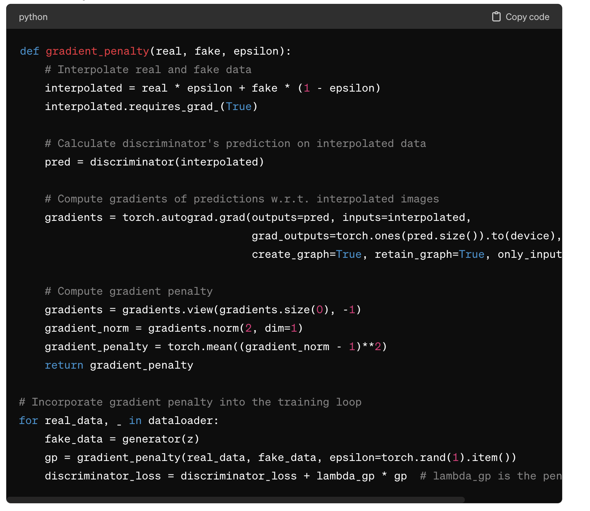
tor_loss + lambda_gp * gp # lambda_gp is the penalty coefficient
- Follow-Up: After the user implemented these suggestions, they observed more stability in training. I engaged in a follow-up discussion to fine-tune other hyperparameters and provided additional tips on monitoring the training process using visualizations like TensorBoard.
Outcome: This interaction not only helped the user stabilize their GAN model but also enriched the community’s understanding of handling similar issues in machine learning model training. My contribution was well-received, and I documented the solution approach in a blog post that later served as a reference for other data scientists facing similar challenges.

Conclusion
Handling technical feedback and questions is not just about solving problems but also about educating and empowering the community. By sharing knowledge and detailed solutions, I aim to contribute positively to the development of robust machine learning practices and collaborative problem-solving within the community.

Example of Resolving a Complex ML/Data Science Issue: unbalanced data producing large FNR for fraud detection
Background: In an online community forum dedicated to machine learning, a user encountered a significant challenge with their XGBoost model applied to a fraud detection dataset. The model exhibited poor performance, particularly with an unusually high false-negative rate, which is critical in fraud detection scenarios.
My Contribution: Understanding the critical nature of the problem in financial contexts, I provided a systematic approach to diagnose and resolve the issue, focusing on feature engineering, model tuning, and evaluation techniques.
- Initial Assessment:
  - Data Exploration: I advised the user to perform an in-depth analysis of the feature distributions and the balance between the fraud and non-fraud classes. Imbalanced data can often lead to model biases toward the majority class.
  - Feature Engineering: I suggested enhancing the feature set with interaction terms and engineered features that might capture more complex patterns specific to fraudulent transactions.
- Advanced Model Tuning:
  - Hyperparameter Optimization: Recommended using grid search and randomized search techniques to find optimal settings for max_depth, min_child_weight, subsample, and colsample_bytree parameters in XGBoost.
  - Handling Imbalanced Dataset: Advised employing the scale_pos_weight parameter of XGBoost, which helps in adjusting the algorithm’s balance towards positive class.
  - Early Stopping: Introduced the concept of early stopping to prevent overfitting.
- Code Example:
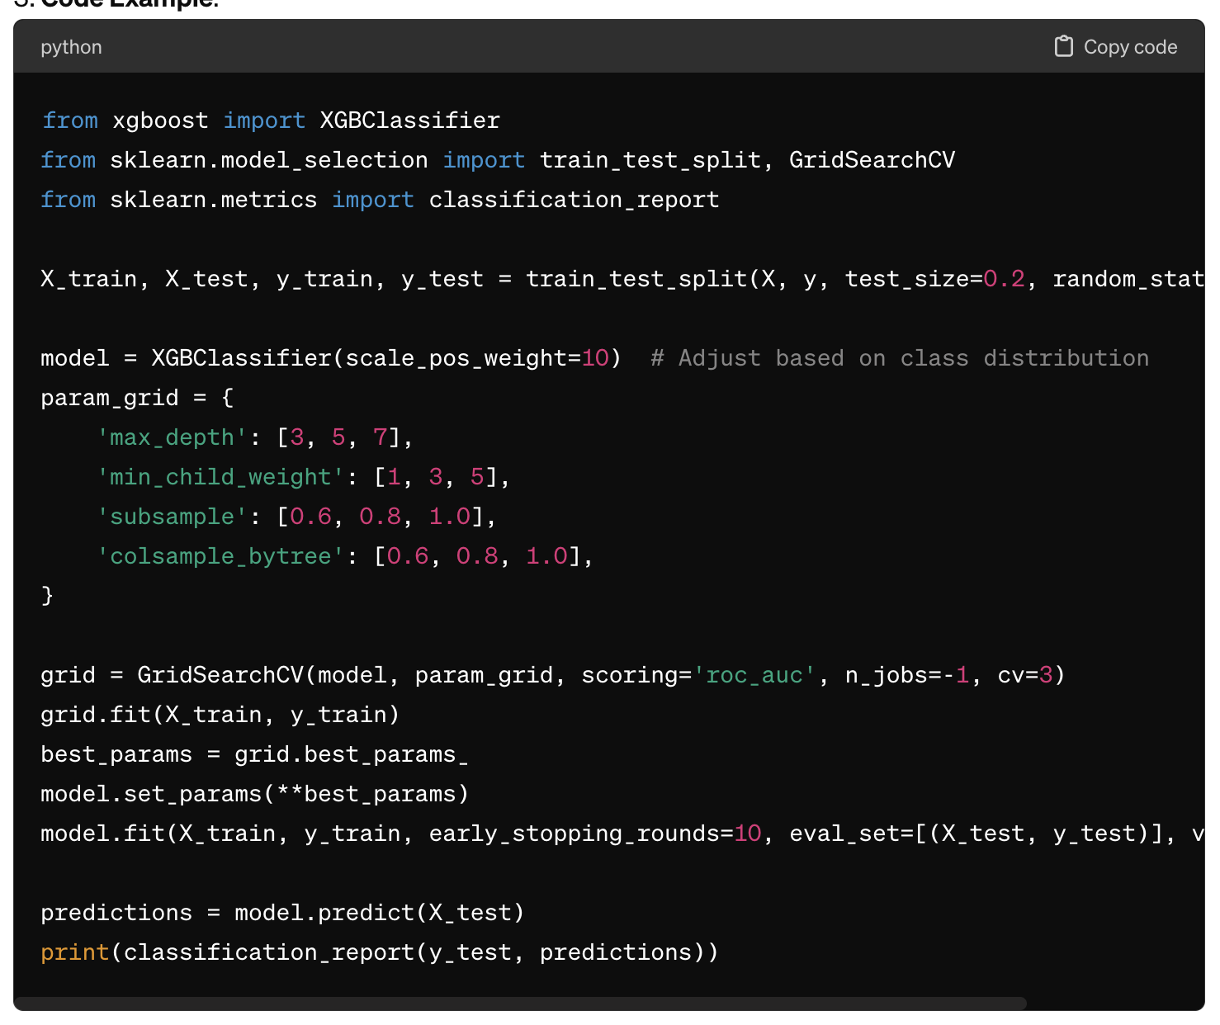
(X_test) print(classification_report(y_test, predictions))
- Evaluation and Feedback:
  - Model Evaluation: Guided the user to assess model performance using not only accuracy but also precision, recall, and the AUC-ROC curve, which are more indicative of performance in imbalanced datasets.
  - Feedback Loop: Encouraged continuous monitoring and feedback collection from the deployment of the model to iteratively improve the detection strategy based on real-world performance.
Outcome: The modifications led to a substantial improvement in model sensitivity to fraud cases, reducing false negatives significantly. The user implemented these suggestions and observed a marked improvement in the detection rates. The forum discussion turned into a collaborative thread, with many participants contributing further suggestions and sharing similar experiences, enriching the community’s collective knowledge.

Based on your list, it seems that AWS offers a variety of GPU-equipped instances that you can configure as a development environment (or "DevBox") tailored to your computational needs. These are indeed specific types of AWS EC2 instances equipped with NVIDIA GPUs, suitable for development, training, and inference tasks. Let's look at each GPU option and understand their suitability:

AWS GPU Instances Overview
- CPU: This likely refers to instances that are optimized for compute operations without dedicated GPU acceleration.
- A10G:
  - Description: NVIDIA A10 GPUs are designed for mixed workloads, balancing graphics and compute tasks.
  - Use Cases: Suitable for graphics-intensive applications as well as AI inference with moderate training requirements.
- A100:
  - Description: NVIDIA A100 GPUs offer cutting-edge performance for deep learning and high-performance computing.
  - Use Cases: Ideal for training complex machine learning models and large-scale scientific computations.
- A100_80GB:
  - Description: Similar to the A100 but with double the memory capacity, providing 80 GB of GPU memory.
  - Use Cases: Best suited for the largest and most memory-intensive AI models and high-performance computing tasks.
- V100:
  - Description: NVIDIA V100 is based on the older Volta architecture but still offers robust performance for AI and HPC.
  - Use Cases: Appropriate for deep learning training and inference, HPC tasks, and data analytics.
- T4:
  - Description: NVIDIA T4 GPUs are oriented towards inference and less intensive training tasks, known for energy efficiency.
  - Use Cases: Great for AI inference, lighter training loads, and serving as a cost-effective option for various ML applications.
- H100:
  - Description: NVIDIA's latest Hopper architecture GPUs, designed for next-generation AI workloads.
  - Use Cases: Optimized for training and deploying AI models, especially those involving complex data types and large-scale neural networks.

Choosing the Right "DevBox" Configuration
The choice among these GPU types should be driven by your specific application needs:
- Memory Intensive Tasks: Choose A100_80GB or H100 if you’re dealing with very large datasets or models that require substantial memory.
- Balanced Performance and Cost: A10G and T4 can offer a good balance for development environments where you need reasonable compute power but also need to manage costs.
- High-Performance Requirements: A100, A100_80GB, and V100 are better suited for intense computational tasks requiring top-tier performance.

Configuring Your AWS "DevBox"
When setting up your virtual "DevBox" in AWS:
- Select the Instance Type: Based on the GPU that fits your needs.
- Configure the Instance: Set up storage, networking, and security features according to your project requirements.
- Install Required Software: Set up the operating system, CUDA toolkit, deep learning frameworks like TensorFlow or PyTorch, and any other necessary software.
This AWS-based "DevBox" setup provides the flexibility to choose the hardware that matches your development needs, accessible via the cloud, allowing you to scale resources as your requirements change.

AWS P3 Instances
- Hardware: P3 instances are equipped with NVIDIA Tesla V100 GPUs. These GPUs are based on the NVIDIA Volta architecture, which was a significant advancement over previous GPU architectures with increased efficiency and computing power.
- Use Cases: P3 instances are well-suited for machine learning and deep learning, high-performance computing (HPC), computational finance, seismic analysis, and similar tasks. They are commonly used for training more complex deep learning models.
- Features: These instances provide high-performance GPU computing capabilities, fast networking, and high throughput, making them ideal for the aforementioned applications.

AWS P4 Instances
- Hardware: P4 instances utilize NVIDIA A100 Tensor Core GPUs, based on the newer NVIDIA Ampere architecture. These GPUs offer improvements over the V100, such as more memory (up to 80 GB of GPU memory per GPU), higher bandwidth, and enhanced performance for AI and machine learning workloads.
- Use Cases: P4 instances are targeted towards the most demanding machine learning and HPC applications. They are particularly effective for tasks requiring massive parallel compute power, such as training large-scale AI models, complex scientific simulations, and large-scale data analytics.
- Features: P4 instances are characterized by their ability to handle larger and more complex computational loads more efficiently, thanks to the advancements in GPU architecture and higher memory capacities.

NVIDIA DevBox A100
- Hardware: The NVIDIA DevBox A100 is not a cloud instance but a physical workstation equipped with NVIDIA A100 GPUs. It's designed as an all-in-one solution for AI researchers and developers.
- Use Cases: The DevBox is ideal for developers who need immediate access to powerful computing resources on their local machine. It is used for developing and testing AI models, simulations, and analytics in a desktop environment.
- Features: The DevBox offers a high degree of control and customization, providing a local environment with potentially up to four A100 GPUs, making it extremely powerful for developing cutting-edge AI applications without the latency or potential limitations of cloud-based resources.

Summary and Comparison
- Location and Accessibility: P3 and P4 are cloud-based solutions provided by AWS, meaning they are accessible remotely and can be scaled quickly based on the user’s needs. The DevBox A100, however, is a physical machine that resides locally, offering direct access and control but with higher initial costs and less flexibility in scaling.
- Performance and Capabilities: While P3 instances are powerful, P4 instances represent the next generation of NVIDIA's GPU technology, offering superior performance, especially for tasks involving AI and machine learning. The DevBox A100 provides similar capabilities to P4 instances but in a personal, dedicated hardware setup.
- Cost Considerations: Using P3 or P4 instances in AWS can be cost-effective for short-term, scalable needs since you pay for the compute time you use. The DevBox A100 requires a significant upfront investment but eliminates ongoing costs associated with cloud computing.
==

Kubernetes
- What It Is: Kubernetes is an open-source container orchestration platform that automates the deployment, scaling, and management of containerized applications. Kubernetes is not tied to a specific cloud provider; it can run on almost any infrastructure, whether it's public cloud, private cloud, or on-premises servers.
- Provider Agnostic: Kubernetes can be used on AWS, Google Cloud, Microsoft Azure, and even on your own hardware. It's a universal system that works across different environments.

AWS (Amazon Web Services)
- Cloud Provider: AWS is a cloud service provider offering a wide range of computing resources and services, including virtual machines, storage, and networking, among others.
- Instance Types: Within AWS, there are various types of virtual machine instances, such as the p3 and p4 series, which are equipped with NVIDIA GPUs and are often used for compute-intensive tasks like machine learning and data processing.

Microsoft Azure
- Another Cloud Provider: Azure is Microsoft's cloud platform, similar to AWS but from Microsoft. It also offers a variety of services including AI, computing, database services, and more.
- Kubernetes on Azure: Azure provides Azure Kubernetes Service (AKS), which is a managed Kubernetes service that simplifies the deployment, management, and operations of Kubernetes on Azure.

Run:AI
- Orchestration Platform: Run:AI is a platform that specializes in orchestrating and managing artificial intelligence (AI) workloads. It builds on Kubernetes to provide additional capabilities tailored for the needs of AI computations, such as better management of GPU resources and advanced queueing mechanisms.
- How It Works: Run:AI uses Kubernetes under the hood to orchestrate containerized AI applications, allowing users to optimize the usage of GPU resources across clusters. It is not a cloud provider but a management layer that enhances Kubernetes for specific types of workloads.

Relationship and Clarification
- Kubernetes vs. AWS/Azure: Kubernetes is a container orchestration tool that can be deployed within AWS or Azure (or any other environment). It's not equivalent to AWS or Azure but is often used within these environments to manage applications.
- Use of p3, p4 Instances: When you mention "p3" and "p4" types, you're likely referring to AWS instance types. These can be used within a Kubernetes cluster managed by Run:AI or another Kubernetes management layer, but they originate from AWS's categorization of their virtual machines.

Your Scenario
- "sensei-platform-p4d": This sounds like it could be a specific project name or a cluster identifier within your organization or within a platform like Run:AI, which is configured to use AWS's p4 instances. This would not be a type of machine but rather a reference to the infrastructure setup being used for a particular purpose.
In summary, Kubernetes is a container orchestration system that can be utilized across different environments, including both AWS and Azure. Run:AI provides specialized orchestration capabilities on top of Kubernetes, focusing on the efficient management of AI workloads, particularly those requiring intensive GPU resources. This setup allows leveraging powerful GPU instances from AWS (like p3 and p4) within a Kubernetes-managed environment.

